Courtney Thurston

AP Art History

Mrs. Eckel

Art of Ancient Rome I

*Fully identify this work of art including the date it was created and subject(s) of the reliefs that decorate it. Briefly discuss how this structure expresses moral ideals and/or political goals important at the time it was created. Provide a single clear and concise paragraph for your answer.*

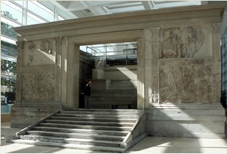

The image above is a photograph of the Ara Pacis Augustae from the Roman Early Empire, circa nine to thirteen B.C.E. Much like in Greek culture, the worship of various deities permeated the Roman culture. This particular work of art comes in the form of an altar, which was dedicated to the goddess of peace. Ironically, the Romans were involved in warfare around this time, and yet artisans took their time crafting this altar—many intricate carving details can be seen both on the altar’s façade and within the structure itself as well. Many of these scenes imply the need for forgiveness, perhaps due to the conflict between the Roman’s idealized concept of peace and the reality of their imperialist empire.